Chapter 16: Confidence Intervals for Proportions

**2011 Yale/George Mason Poll Example:**

1. Open a new excel sheet.
2. Use **CONFIDENCE.NORM** function to calculate the margin of error.



where **alpha $\left(α\right)$** is the significant level. A significant level 0.05 indicates a 95% confidence level.

**standard_dev** is the standard deviation of the sample proportion, and we need to use **SQRT** function to calculate it.

**size** is the sample size (n).

1. Using the textbook example: sample size (n) = 1010, sample proportion (p) = 0.40, and we need a 95% confidence interval.

|  |  |
| --- | --- |
| Sample Proportion (p) | = 0.40 (given) |
| q = 1 - p |  |
| Sample Size (n) | = 1010 (given) |
| Confidence Level (1 - α) | = 0.95 (given) |
| Significant level (α) |  |
| SD (p) |  |
| Margin of Error (ME) |  |
| Lower Confidence Level (L) |  |
| Upper Confidence Level (U) |  |

The **SQRT** function gives the square root of the value.

1. The result is

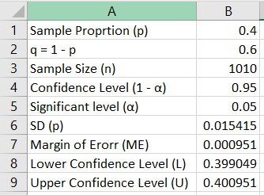

The 95% confidence interval is (0.399, 0.401)